Photodiodes at cryogenic temperatures

Background
The responsivity of photodiodes can be estimated from fundamental constants, the wavelength of the radiation, the reflectance and internal losses of the photodiodes. Newly developed 3D models for silicon photodiodes are used at Justervesenet (JV) to accurately predict the internal losses of the photodiodes at room temperature, making them a predictable standard detector with a responsivity linked to fundamental constants. The recombination of electrons and holes at the surface is the main process limiting the internal quantum efficiency.. However, the numerical models predict that these losses should be reduced by one to two orders of magnitude when the diodes are cooled down to 77 K. The new models and method to predict the responsivity of photodiodes can therefore be exploited to develop photodiodes of unprecedented accuracy at cryogenic temperatures, enabling capabilities to measure fundamental constants like e/h. Passivation with SiO2 and SiNx thin films is currently used to reduce surface recombination, and it is therefore of high importance to investigate the defect states at these surfaces with changing temperature.
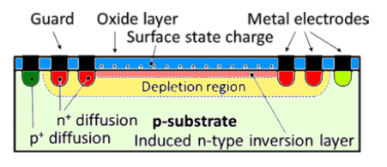 | 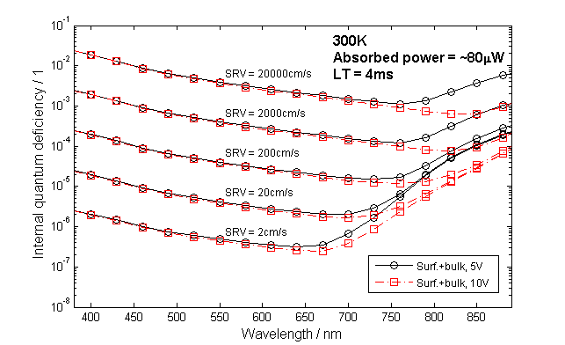
Figure 1. Schematic of induced junction detector (Front passivation layer in blue). | Figure 2.Simulated Internal quantum deficiency as a function wavelength for different SRV parameters.
Task
Grow passivation layers of different materials, supported with charge increasing techniques, and measure minority carrier lifetime at different temperatures to identify the passivation layer that works best at cryogenic temperatures. The project will involve building and development of a new measurement stage for this purpose. The outcome of the project will outline design of photodiodes that are orders of magnitude better than current state-of-the-art and suitable as the new primary standard to measure fundamental constants e/h.

Additional information
The laboratory work will be made at IFE Kjeller and simulations in collaboration with JV.

Contact person
Jarle Gran, Justervesenet, | Halvard Haug, IFE
jag@justervesenet.no | halvard.haug@ife.no
64 84 84 45 | 99 48 67 57

References
- J. Gran, et. al.:”Simulations of a predictable quantum efficient detector with PC1D”, Metrologia, 49 (2012), S130-S134.
- C. K. Tang et. al.: «Measured and 3D modelled quantum efficiency of an oxide-charge induced junction photodiode at room temperature», NUSOD (2015), Taipei, 7 – 11 sept. 2015, DOI: 10.1109/NUSOD.2015.7292880

